1.What approximate value should come in place of question mark (?) in the following questions? (Note: You are not expected to calculate the exact value)



1. 35

2. 40

3. 54

4. 60

5. 48

Solution:

**2.** What approximate value should come in place of question mark (?) in the following questions? (Note: You are not expected to calculate the exact value)



1. 700

2. 720

3. 770

4. 800

5. 740

Solution:

**3.**What approximate value should come in place of question mark (?) in the following questions? (Note: You are not expected to calculate the exact value)



1. 700

2. 600

3. 500

4. 550

5. 680

Solution:

**4.** What approximate value should come in place of question mark (?) in the following questions? (Note: You are not expected to calculate the exact value)



1. 2025

2. 2300

3. 1925

4. 2200

5. 1700

Solution: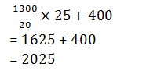

**5.** What approximate value should come in place of question mark (?) in the following questions? (Note: You are not expected to calculate the exact value)



1. 250

2. 325

3. 275

4. 300

5. 350

Solution: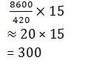

**6.** What approximate value should come in place of question mark (?) in the following questions? (Note: You are not expected to calculate the exact value)



1. 450

2. 300

3. 230

4. 280

5. 350

Solution: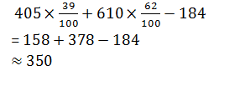

7.What should come in place of question mark (?) in the following given questions(just calculate the approximate value) ?



1. 80

2. 95.5

3. 130

4. 125.5

5. 115

Solution:

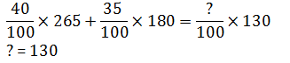

**8.** What should come in place of question mark (?) in the following given questions(just calculate the approximate value) ?



1. 15

2. 24

3. 37

4. 49

5. 53

Solution:



**9.** What should come in place of question mark (?) in the following given questions(just calculate the approximate value) ?



1. 6

2. 4

3. 12

4. 16

5. 26

Solution:



**10** What should come in place of question mark (?) in the following given questions(just calculate the approximate value) ?



1. 36

2. 26

3. 46

4. 30

5. 12

Solution:



**11** What should come in place of question mark (?) in the following given questions(just calculate the approximate value) ?



1. 6

2. 12

3. 32

4. 64

5. 8

Solution:

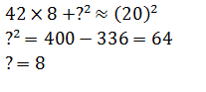

**12** What should come in place of question mark (?) in the following given questions(just calculate the approximate value) ?



1. 225

2. 230

3. 237

4. 245

5. 320

Solution:

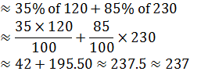

13.Find out of the approximate value of ? in the following questions



1. 50

2. 60

3. 75

4. 70

5. 55

Solution:

**14.** Find out of the approximate value of ? in the following questions



1. 20

2. 25

3. 22

4. 15

5. 18

Solution:

**15.** Find out of the approximate value of ? in the following questions



1. 7

2. 8

3. 6

4. 9

5. 5

Solution: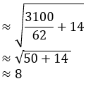

**16.**Find out of the approximate value of ? in the following questions



1. 34

2. 19

3. 39

4. 29

5. 38

Solution: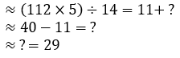

**17.** Find out of the approximate value of ? in the following questions



1. 3

2. 4

3. 5

4. 7

5. 6

Solution:

**18.** Find out of the approximate value of ? in the following questions



1. 4950

2. 4820

3. 5550

4. 5340

5. 5260

Solution: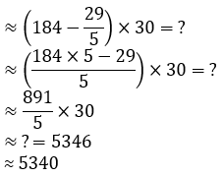

19.What approximate value should come in place of the question mark (?) in the following questions?

1814.9 ÷ 121) × 35.78 ÷ 45.1023 = ?

1. 12

2. 25

3. 10

4. 30

5. 40

Solution:

≈12

**20.** What approximate value should come in place of the question mark (?) in the following questions?

3945 + 150 × 40 – 35.5 = ?

1. 9000

2. 10000

3. 9500

4. 9900

5. 9950

Solution:

≈9945-35

≈ 9900

**21.**What approximate value should come in place of the question mark (?) in the following questions?



1. 14070

2. 15080

3. 13040

4. 14089

5. 15800

Solution:

≈15800

**22.**What approximate value should come in place of the question mark (?) in the following questions?

3.5 × 0.7 ÷ 1.7= ?

1. 4

2. 3

3. 1.5

4. 5

5. 2

Solution:

≈ 1.5

**23.** What approximate value should come in place of the question mark (?) in the following questions?



1. 131

2. 141

3. 151

4. 161

5. 171

Solution:

≈102+46.8+1.8

≈151

19.What approximate value will come in place of (x) in the following questions ?



1. 1/16

2. 1/9

3. 1/25

4. 1/4

5. 1/36

Solution: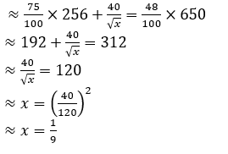

**20.**What approximate value will come in place of (x) in the following questions ?



1. 6

2. 7

3. 8

4. 10

5. 12

Solution: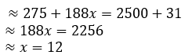

**21.** What approximate value will come in place of (x) in the following questions ?



1. 8

2. 6

3. 13

4. 5

5. 11

Solution: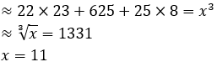

**22.** What approximate value will come in place of (x) in the following questions ?



1. 900

2. 2500

3. 1600

4. 400

5. 3600

Solution: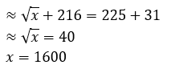

**23.**What approximate value will come in place of (x) in the following questions ?



1. 24

2. 23

3. 20

4. 18

5. 26

Solution: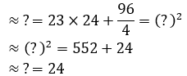

**24.** What approximate value will come in place of (x) in the following questions ?



1. 3200

2. 3100

3. 3400

4. 2800

5. 2100

Solution: